Using HashiCorp Terraform, please create the following:

1. Create an IAM role.
2. create a granular appropriate that are going to be used ipolicy for your task.
3. Associate this role with the created role.
4. Using this role, create some AWS resources that are going to be used in your infrastructure.
5. Disassociate the policy from the role.
6. Remove the role.

**Step 1: Create the Terraform Configuration:**

<https://github.com/abha2805/CloudSecurity/tree/main>

**Step 2: Initialize Terraform, plan your deployment, and apply your configuration.**

terraform init

terraform plan

terraform apply

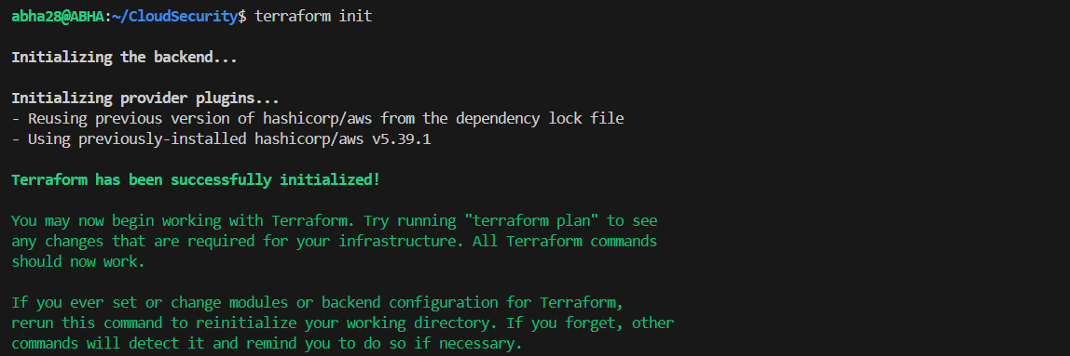



**Step 3: Remove the Policy and Role**

Now that the infrastructure is up and running, update and remove the resources related to the IAM role and policy.

{refer detach_policy branch}

<https://github.com/abha2805/CloudSecurity/tree/dettach_policy>

aws_iam_policy,

aws_iam_role_policy_attachment,

aws_iam_role,

aws_iam_instance_profile

This step will disassociate the policy from the role and remove the role, leaving your infrastructure running with the created AWS resources but without the specific IAM role or policy.

